CS 255 System Design Document Template

UML Diagrams

UML Use Case Diagram

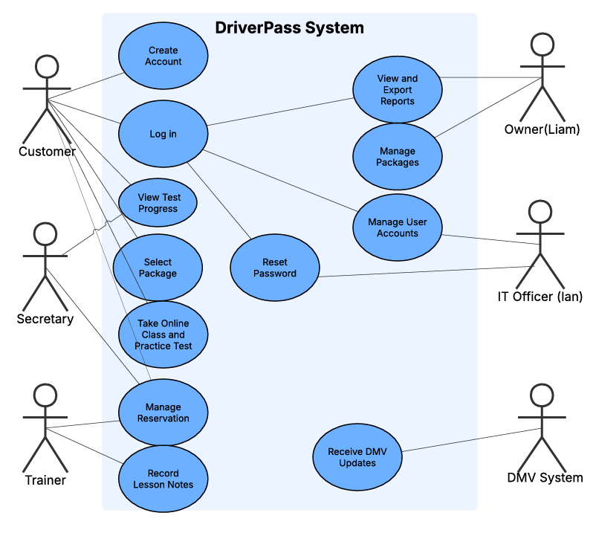

UML Activity Diagrams
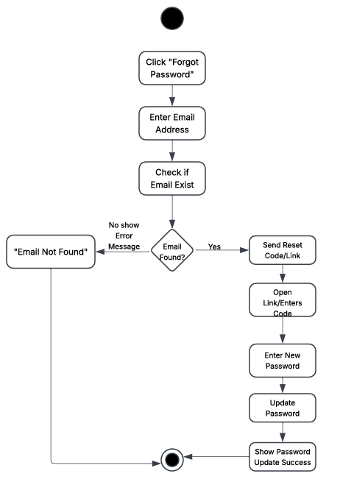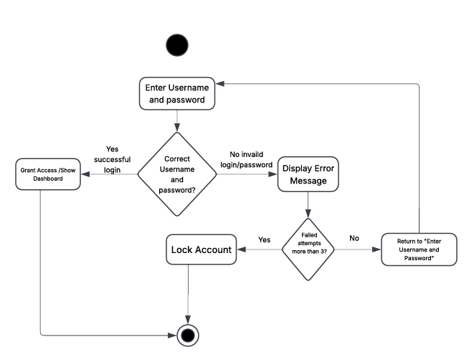

UML Sequence Diagram
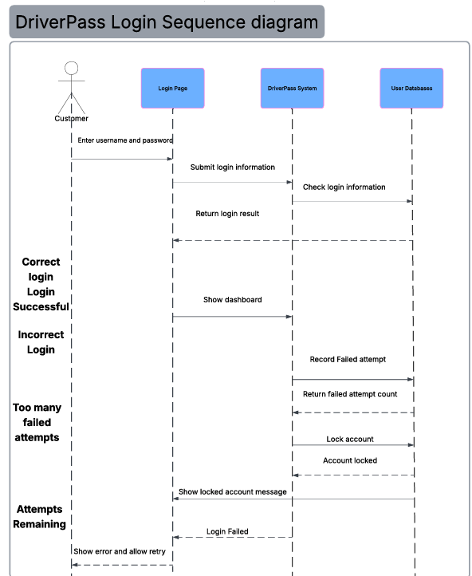

UML Class Diagram

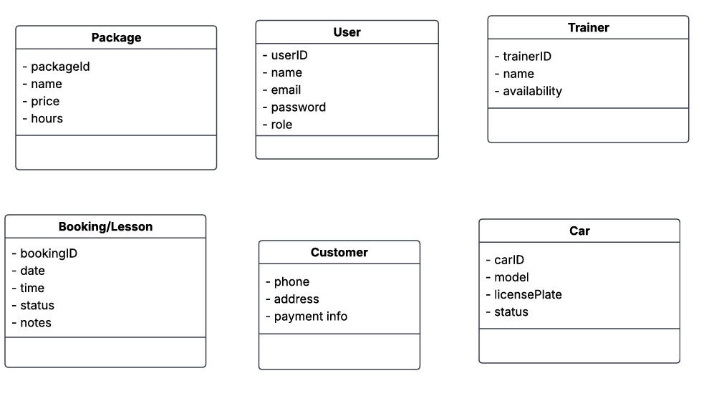

Technical Requirements

Hardware Requirements

The DriverPass system will need computers and devices that allow customers and employees to access the system. Customers should be able to use a computer, laptop, tablet, or smartphone to log in, schedule driving lessons, and complete practice tests. Employees will need computers or tablets to manage customer information, reservations, and reports. The system will also need servers to store and process information. Using cloud-based servers would allow DriverPass to access the system without having to maintain all the equipment at their business location.

Software Requirements

The DriverPass system will need software that allows users to create accounts, log in, and access the different features. A web-based application would allow customers and employees to use the system through an internet browser without downloading additional programs. The software will need a database to store customer accounts, lesson schedules, package information, and test progress. It should also allow employees to update reservations and record lesson notes. The system will need to receive DMV updates so customers have access to current information for their driving tests.
Tools Requirements

Development tools will be needed to design, build, and test the DriverPass system. Lucidchart can be used to create the UML diagrams that show how different parts of the system work together. Developers will also need programming tools to build the website and connect it to the database. Testing tools will be important to make sure customers can log in, reset passwords, schedule lessons, and use the system correctly. These tools will help identify problems before the system is available to customers.

Infrastructure Requirements

The DriverPass system will need a reliable internet connection and secure hosting to keep the website available to customers and employees. Cloud hosting would allow users to access the system from different locations. The system should also have regular backups to help prevent important information from being lost. Security features will be needed to protect customer information, including encrypted connections, secure password storage, and access based on each user's role. Payment information should be handled through a secure payment service rather than storing full card details in the DriverPass database. The system will also need regular updates and maintenance to keep it working properly and protect against security threats.

